EOD Estimator – SOP
1. Purpose
This utility connects to PostgreSQL store databases, reads recent POSLOG batch timestamps, and reports:
- Average POSLOG time of day (excluding weekends, if applicable).
- Latest POSLOG date/time (optional, if enabled).
It is intended to help operations estimate when POSLOG is typically generated per store.
2. Scope and Prerequisites
- Java 8 or higher installed.
- Maven installed.
- Network access from the machine to the target PostgreSQL store databases.
- Valid database credentials configured in DbDetailsBuilder.
- PostgreSQL JDBC driver declared in pom.xml.
3. Input Preparation
- Open input.txt in the project root.
- Add store codes, one per line, in the format:
  - Two-letter country code followed by 3 or 4 digits.
  - Examples:
    - DK121
    - CA1094
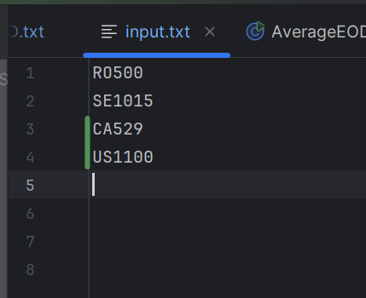
- Save the file.
4. Running the Utility
4.1 Build
From the project root:
Run: mvn clean package
4.2 Execute
Run the main class:
AverageEod.java – To calculate the average EOD time of individual stores.
EodCheck.java – To check if the EOD is complete for the particular stores
The program will:
- Read each store code from input.txt.
- Connect to each store's PostgreSQL database.
- Compute and record POSLOG timing information.
5. Output
- After the run completes, open AverageTimings.txt in the project root for AverageEod.java, and TodaysEOD.txt for EodCheck.java
- The output will be as follows,

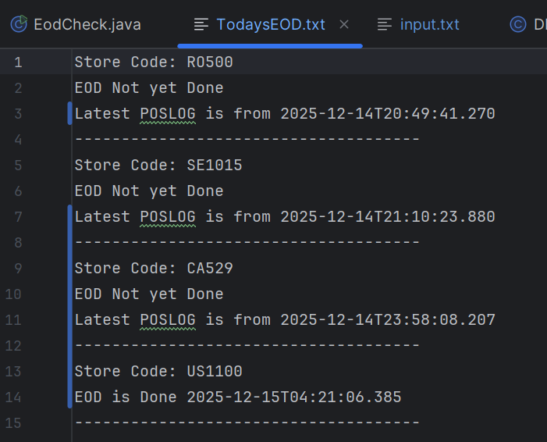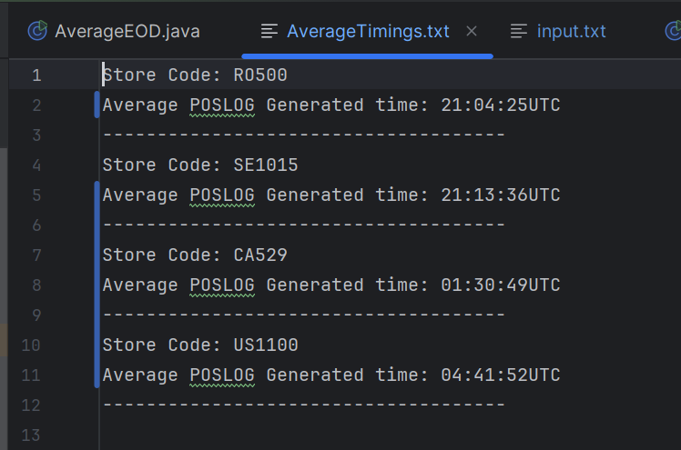

  - Average POSLOG Generated time: approximate time of day(UST) when POSLOG is generated for that store.
  - Latest POSLOG ...: timestamp of the most recent POSLOG, used to verify that the store is up-to-date.
6. Error Handling and Troubleshooting
"Error reading input.txt"
- Check that input.txt exists in the project root and is readable.
- Verify file encoding is standard text (UTF-8 or similar).
"No POSLOG found" / "No weekday POSLOG found"
- The batch table may not have any batch_type = 'POSLOG' rows, or only weekend data when weekends are excluded.
- Confirm table name, column names, and filter conditions in BatchDao.
Database Connection Failures
- Confirm that the host pattern constructed in DbDetailsBuilder is correct for the store.
- Check credentials (username/password) and port.
- Test connectivity with a DB client using the same JDBC URL.
7. Maintenance and Configuration Changes
- To change database credentials or host naming rules, edit DbDetailsBuilder.
- To change how many POSLOG records are used for the average, adjust the LIMIT in the SQL query in BatchDao.
- To change weekend/weekday logic or add holidays, adjust the filtering in BatchDao where timestamps are selected or filtered.

